

**Artificial Intelligence and Data Science Department.**

AOA / Even Sem 2021-22 / Experiment 7.

YASH SARANG.

47 / D6AD.

EXPERIMENT - 7.

**___________________________________________________**

**Aim:** Write a program for All Pairs Shortest Path.

(Floyd Warshall Algorithm)

**___________________________________________________**

**Theory:**

**Floyd Warshall Algorithm :**

We initialize the solution matrix same as the input graph matrix as a first step. Then we update the solution matrix by considering all vertices as intermediate vertex. The idea is to one by one pick all vertices and update all shortest paths which include the picked vertex as an intermediate vertex in the shortest path. When we pick vertex number k as an intermediate vertex, we already have considered vertices {0, 1, 2, .. k-1} as intermediate vertices. For every pair (i, j) of the source and destination vertices respectively, there are two possible causes:

1) k is not an intermediate vertex in the shortest path from i to j. We keep the value of dist[i][j] as it is.

2) k is an intermediate vertex in the shortest path from i to j. We update the value of dist[i][j] as dist[i][k] + dist[k][j] if dist[i][j] > dist[i][k] + dist[k][j]

**Time Complexity:** O(n^3) **___________________________________________________**

**CODE:**

Code is in the AllPairShortestPath-FloydWarshall.c file attached along with this doc.

**___________________________________________________**

**INPUT:**

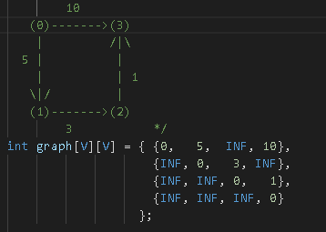

**OUTPUT:**

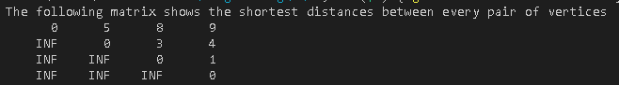

**___________________________________________________**

**CONCLUSION:**

The above program only prints the shortest distances. We can modify the solution to print the shortest paths also by storing the predecessor information in a separate 2D matrix.

Also, the value of INF can be taken as INT_MAX from limits.h to make sure that we handle the maximum possible value. When we take INF as INT_MAX, we need to change the if condition in the above program to avoid arithmetic overflow.

**___________________________________________________**